Biographical Notes and Lineage for
CAPT. ANTEUNIS/TUNIS HOOD AND DESCENDANTS
Tunis Hood was one of Mecklenburg County's most prominent citizens. He was county commissioner for 10 years, and third largest plantation owner, owning 2,000 acres of land along the McAlpine Creek. He provided supplies for the patriots during the American Revolution. He was a Dutch farmer, born in New York, and raised in the Shenandoah Valley of Virginia.
Tunis followed his sons to Mecklenburg County, NC, in 1775 where he died in 1797.
A sixth cousin of Elvis, and gggranddaughter of Tunis Hood, Rustee Lane, President of the Mint Hill NC Elvis Fan Club, took the last full measure of honoring our history and heritage by insuring that Tunis Hood, progenitor of the Hood clan, received a special plaque and dedication, attended by many of his descendants still living in Mint Hill, North Carolina.</b> This was the Hood family tribute to Tunis, whose burial place in an unkempt 200-year old cemetery was marked only by a fieldstone with the initials “T.H.” etched on it. Dr. Chris Hood replaced the stone in 1989 with the one shown in the photo. During the ceremony, the Hood family descendants in NC also paid tribute to cousin Elvis and cousin, Minnie Mae Hood, also descendants of Tunis, by placing a marker to Minnie Mae below that of her ancestor. Rustee did a masterful service to the Hood family and all Hood relations, and to the memory of Elvis and Minnie Mae, and we thank her for all her diligent efforts in putting this together. The Hoods and Presleys lived side-by-side and knew one another since the early days in North Carolina.
The Hood family became associated with the Harrison family through Tunis Hood's marriage to Elizabeth Harrison, daughter of Samuel Harrison and Abigail Smith. The Harrison line gave us three Presidents: Benjamin Harrison, William Henry Harrison, who died while only one month in office, and Abraham Lincoln, a ggrandson of Isaiah Harrison.
Minnie Mae Hood's father was William Hood married to Mary Warren. Joshua Hood, Minnie Mae's ggrandfather, and his wife, Margaret Johnson, left NC and moved to Alabama before migrating further to Fulton, MS, where he owned a cabin that is still standing today in Itawamba County. (photo below). In Alabama, three of the Johnson sisters married three Helms brothers.
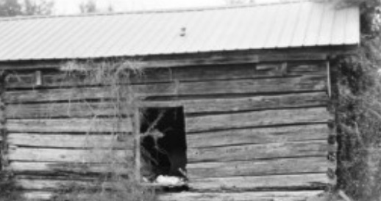
Minnie Mae's brother was Harrison Hood. The Harrison, Hood, Helms, and other linking families came to North Carolina from Augusta County, VA.
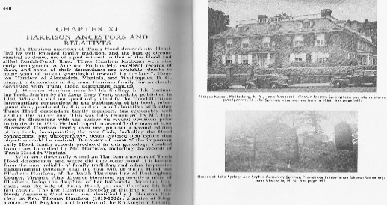
Revolutionary War Patriot
This symbol shows that a person(s) in this lineage has served in the American Revolution and their descendants are eligible for membership in either the DAR or the SAR. Capt. Anteunis/Teunis/Tunis Hood served in the American Revolutionary War and his ancestral information is with the DAR headquarters. Descendants have applied for membership through his descendant lines. For further information, or if you need any help on how to join, or how to obtain these records, please click the contact tab to message Barbara Lee.

Hood Family
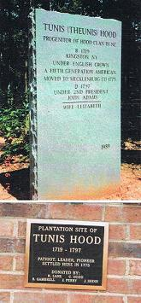
Grave of Capt. Teunis/<br>Tunis Hood, Mint Hill, NC
Capt. Teunis Hood Monument, top, with Minnie Mae Hood Memorial plate, below
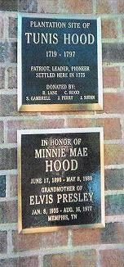

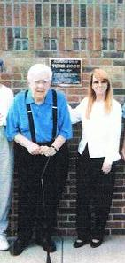Dr. Chris Hood, here with Rustee Lane, was responsible for placing the present-day tombstone for Tunis placed in 1989.
Tunis Hood Family descendants of Mecklenburg County, NC. (below)
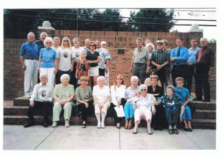

Hood Family Lines

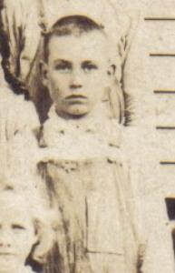
Family of Earl Willis and Lucille McMillen
submitted by Sheila Brown. Photo at top is Earl Willis at 12 years old, 1922.
Maternal Line of Sheila Brown, ggranddaughter of Earl and Lucille Willis
1. Jasper (Hoed) Hood b: 1671 in Denmark married Cathrina (Trynje) Andries b: Abt. 1670 in New Amsterdam, New York City
2. Luykas(Lucas Hoed) Hood b: October 02, 1708 in New Amsterdam, New York d: May 07, 1771 in Fredricks Co. W V ( Berkley Co.) married Johannah (Johannah) Van Stockholm
3. Andrew "Major" Sr. Hood b: 1747 in Frederick County, Virginia d: 1805 in Greenup County, Kentucky m. +Massa Suddeth b: 1748 in Frederick County, Virginia
4. Andrew Hood b: May 20, 1810 married Emily Stewart b: 1810 d: 1867 in Pierce Cemetery, Hopewell, KY. Andrew Hood Source: 1850 Greenup County, Kentucky Census b: 1784 d: May 1884 in Wurtland, Kentucky married Mary 'Polly Caine b: Bef. 1787
5. Lucinda Hood b: September 05, 1849 in Lawrence, KY d: September 25, 1933 in Carter, KY married Gabriel Penn Stephens b: March 28, 1840 in Morgan County KY d: September 09, 1922 in Greenup County, Ky
6. Alice Stephens b: May 07, 1872 in Greenup County, Kentucky d: January 08, 1919 in Carter County, Kentucky married George W. Willis
7. Charles Willis b: July 1888 in Greenup County, Kentucky d: October 07, 1966 in Greenup County, Kentucky. married Effie Adkins b: May 18, 1891 d: March 01, 1920 in Carter County, Kentucky
8. Earl Willis b: November 10, 1910 in Greenup Co. Ky. d: 1995 in Carter County Kentucky married Lucille McMillen

THE PATERNAL LINE OF SHEILA BROWN
Direct Descendants of Jasper (Hoed) Hood

1. Jasper (Hoed) Hood b: 1671 in Denmark married Cathrina (Trynje) Andries b: Abt. 1670 in New Amsterdam, New York City
2. Luykas(Lucas Hoed) Hood b: October 02, 1708 in New Amsterdam, New York d: May 07, 1771 in Fredricks Co. W V ( Berkley Co.) married Johannah (Johannah) Van Stockholm
3. Andrew "Major" Sr. Hood b: 1747 in Frederick County, Virginia d: 1805 in Greenup County, Kentucky married Massa Suddeth b: 1748 in Frederick County, Virginia
4. Andrew Hood Source: 1850 Greenup County, Kentucky Census b: 1784 d: May 1884 in Wurtland, Kentucky married Mary 'Polly Caine b: Bef. 1787
5. Andrew Hood b: May 20, 1810 married Emily Stewart b: 1810 d: 1867 in Pierce Cemetery, Hopewell, KY
6. Amanda Hood b: Abt. 1853 in Carter County Ky. d: September 12, 1936 in Greenup County Ky. Gilbert Stephens b: May 1851 in Morgan County Ky. d: April 21, 1928 in Greenup, County
7. James Harmon Stephens b: June 05, 1877 in Greenup Co. Ky. d: January 29, 1950 in Eastern State Hospital, Fayette County, Kentucky married Jenny Mae Allen b: May 07, 1893 in Floyd County, Kentucky d: August 3, 1983 in Our Lady Of Bellefonte Hospital
In the 6th Generation it was 2 Sisters that married Brothers...
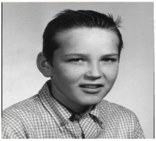
Nine of the ten children of Earl Willis and Lucille McMillen. Standing: Rex, Pat, Jean, Karen, Linda, Lou, Kathy and Mike. Sitting is Gary and above is Gary.
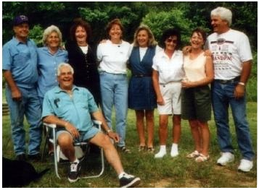
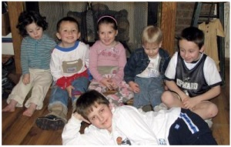
The Brown grandchildren
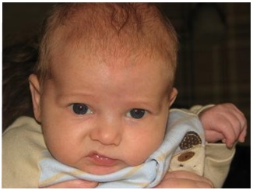
Jaxson Brown looking a bit like Elvis

Cabel Willis. Cabel Willis, brother of Earl, shown here in a photo taken shortly before his death by accident. He was just 14 years old. According to Sheila, the Willis boys mother died when Earl was ten years old. She had lost several children, most of them very young.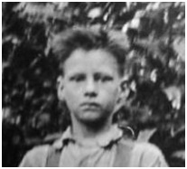

IRA HOOD LINE
The following letter and photos were submitted by Cynthia Clontz, 6th ggranddaughter of Capt. Teunis/Tunis Hood. Ira Hood photo first below.
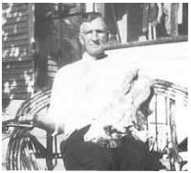
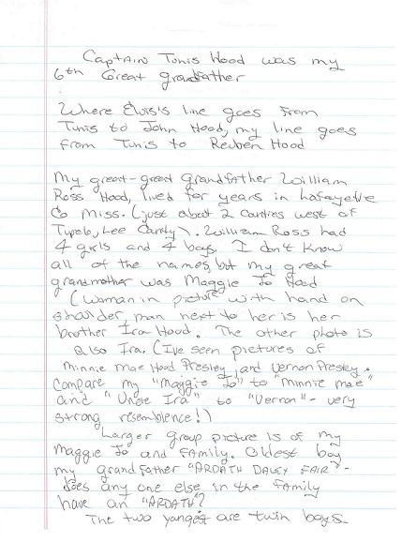
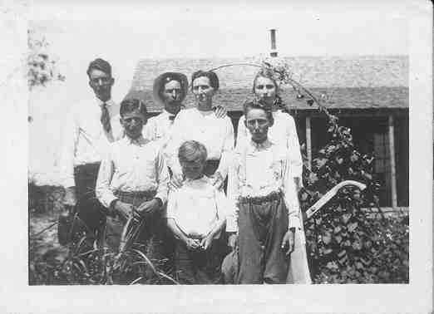Ira and Jo Hood and family

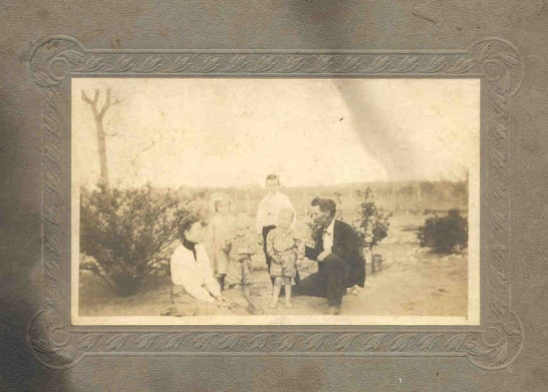Maggie Jo Hood and family

